|  |
| --- |
| Intelligent Reasoning Systems Project |
| **Title:** Intelligent Care and Resource Matching Platform  **Group:** 2   |  |  | | --- | --- | | **Name** | **NUS ID** | | Ashira Wee | A0243826B | | Lin Mingjie | A0330090W | | Yan Binghao | A0291825X | | Zhao Hongming | A0150137R | | Zhao Yisen | A0328788E | |

|  |
| --- |
|  |

Table of Contents

Business Case 3

Executive Summary 3

Product Description 4

Key Features 4

Strategy 5

Strategic Fit and Purpose 5

Product Positioning 5

Long-Term Outlook 6

Market Analysis 6

Market Context 6

Market Opportunity 7

Target Market 8

Competitive Landscape 8

Financial Analysis 9

Plans 10

Project Roadmap 10

Risk and Mitigation Plan 11

System Design 11

Scope 11

Architecture Overview 12

Component-Level Design 13

Health Monitoring Rule Engine 13

Activity Recommendation 14

RAG Pipeline 16

Hybrid Routing for Chatbot 16

User Interface 18

Data Design 19

Activity 19

System Development 21

Implementation Process 21

Development Methodology 21

Development 22

Testing 22

Integration 22

Tools and Technologies 23

Findings 24

References 26

Appendices 27

Appendix A – Output from Activity Recommendation Model 27

Appendix B – Output from RAG 32

Appendix C – Output from Rule-based Engine 33

Appendix D – Project Proposal 35

Appendix E – Mapped System Functionality to Course Knowledge 35

Appendix F – Installation & User Guide 35

Part 1: Installation Guide 35

Part 2: User Guide 37

# Business Case

## Executive Summary

Singapore’s rapidly ageing population presents critical challenges in eldercare, with one-third of elderly individuals living alone as of 2024, heightening the risks of social isolation and dependence on external support. The traditional care model will face increasing pressures as the nation continues to age further with the proportion of working adults to elderly set to decrease even further. To help seniors live independently and safely, there is a need for an accessible solution that addresses both health and social wellbeing.

Our proposed Intelligent Care and Resource Matching Platform is designed to meet these needs through three main functions:

* Monitor vital signs through wearable devices and raises alerts for caregivers or social workers when irregular reading is detected
* Personalised activity recommendations that take into account each user's interests, preferences, and home location
* An intuitive chatbot that enables users to make enquiries on health-related questions or explore activity options using everyday language

The platform delivers significant value to Singapore’s ageing community by improving both independence and quality of life for seniors. Seniors using the platform can live with the assurance that their health is being watched over and that any warning signs will trigger timely alerts. This sense of reliability supports both independence and emotional comfort. Together with tailored activity recommendations, it helps maintain both social connection and mental wellbeing. As participation grows, the burden on caregivers and community resources will also naturally become lighter.

## Product Description

The Intelligent Care and Resource Matching Platform integrates AI components to help seniors live independently and safely. It brings together health monitoring, anomaly detection, and personalised activity recommendations into a single accessible platform. The solution addresses two key challenges that comes up with ageing population, the need for early detection of health issues and the growing risk of social isolation among seniors who live alone. Most current tools only handle one side of senior care, such as tracking health readings or listing activities. This platform connects both, so seniors can look after their health and stay socially active through one system. Over time, this integration can serve as the foundation for a broader “super app” model that brings together more aspects of eldercare and community support.

### Key Features

1. **Health Monitoring and Alerts**

The platform collects vital sign data such as blood pressure, blood oxygen, blood sugar, and heart rate from wearable devices. Its rule-based detection uses clinically defined thresholds to identify abnormal readings. Results outside these thresholds prompt an alert to caregivers or social workers who can then decide on the next steps. This approach keeps monitoring transparent, evidence-based, and consistent with healthcare guidelines.

1. **Personalised Activity Recommendations**

The platform uses demographic and behavioural information such as age, interests, preferred language, budget, and home location to recommend community activities that suit each senior’s circumstances. Many seniors struggle to sort through long lists of events or may not take the initiative to find suitable ones. The platform makes this process easier by recommending a smaller set of activities that fit their interests and circumstances, increasing the likelihood of participation and strengthens social involvement.

1. **Conversational Chatbot Interface**

The platform includes a chat feature that seniors allow seniors to either use text or voice to interact with the platform. Through the chat, seniors can ask general health questions or explore local programmes that match their interests. Rather than working through complex menus, they can enter a short message in plain text. This approach makes the platform easier to use for those with limited digital experience.

## Strategy

### Strategic Fit and Purpose

Singapore’s efforts to help seniors age actively and meaningfully are guided by the Action Plan for Successful Ageing (Ministry of Health, 2023) and the Age Well SG programme (Ministry of Health, 2023). The Intelligent Care and Resource Matching Platform supports these initiatives by promoting health, participation, and social connection among seniors

Our platform contributes to two main goals of the Action Plan for Successful Ageing: Care and Connectedness. For "Care", it enables early detection of potential health issues through continuous monitoring and alerts. For “Connectedness,” the platform connects seniors with programmes that match their interests and promote community participation. In combination, they reflect the Action Plan’s intent to support seniors in living well and remaining part of their communities.

The platform also supports Age Well SG, a national programme that encourages active ageing, enhances home safety, and builds stronger community care networks. It advances these aims by recommending activities that promote engagement and issuing alerts that offer reassurance and safety within the home.

As part of Singapore’s ageing agenda, the platform aims to improve preventive health and community participation among seniors. This coordinated focus supports early intervention and reduces future strain on care networks.

### Product Positioning

The Intelligent Care and Resource Matching Platform is designed as an integrated digital solution that connects two key aspects of eldercare: health management and social participation. Many existing tools address these needs separately, offering either health monitoring features or directories of community activities, but rarely both in a cohesive way.

Its competitive strength lies in addressing two pressing challenges within Singapore’s ageing population: the need to monitor a wider range of health indicators and to help seniors identify community activities that suit their needs and preferences. On top of that, we placed a strong emphasis on ease of use to promote continued engagement. Together, our solution offers a clear advantage over more complex or single-purpose solutions.

### Long-Term Outlook

The long-term vision is for the Intelligent Care and Resource Matching Platform to evolve into a “super” app that brings together different aspects of senior care in one place. As digital familiarity grows among seniors, the platform could gradually move beyond health monitoring and activity matching to include tools that make everyday interaction easier and more meaningful. The next phase of development could add games that promote both physical and mental exercises, expand access to wellness resources, and include multilingual options to make participation easier.

Sustained growth will come from building more partnerships with external agencies as it will expand the base of available activities for seniors. As operations scale, formal data-sharing and API integration will also be required to maintain reliable information flow and accurate recommendations.

As the platform grows through new features and partnerships, it can remain practical and appealing to seniors. This approach strengthens its relevance and encourages continuous participation.

## Market Analysis

### Market Context

The proportion of citizens and permanent residents aged 65+ increased from 11.2% in 2014 to 18% by 2024. A jump of 6.8 percentage points in such a short time is a strong signal of change. Current figures show that nearly one third of seniors live without younger family members in their households. Specifically, 87,200 older adults live alone while 171,600 reside exclusively with other seniors, totalling approximately 258,000 individuals in these living situations (Key Indicators on the Elderly, 2025). This significant portion of the senior population may require additional external assistance for their daily needs.

As the population ages, chronic health conditions present an escalating concern. Projections by Guo et al. (2025) suggest that diabetes rates in individuals over 51 may grow by 4.2%, with hypertension increasing by 4.5% within the same demographic by 2050. The study also points out that around half of the older population in this group may be living with at least one chronic illness, a trend that could place further strain on care systems.

### Market Opportunity

These demographic and lifestyle changes are fuelling demand for tech-enabled eldercare, influenced by three main factors: seniors’ preference to age in place, the mounting health and social needs of an ageing population, and greater acceptance of digital solutions among older adults.

1. **Ageing in Place**

In a 2024 survey conducted by Singapore Management University, 82.8% of older adults in Singapore indicated a wish to stay in their own homes as they grow older (Fang, 2024). This preference carries added weight when viewed in light of the projected rise in Singapore’s senior population. By 2050, seniors are expected to make up roughly one-third of the population (Xiang et al., 2021). With the share at about one in five today, it is evident that home-based care will play a larger role in supporting safe and independent ageing.

1. **Growing Health and Social Challenges**

Singapore’s elderly population is increasingly affected by chronic conditions. Projections suggest that diabetes and hypertension will each rise by around four percent by 2050 (Guo et al., 2025). Alongside this, nearly one-third of seniors live without younger relatives (Key Indicators on the Elderly, 2025), which can heighten the risk of isolation. Caregivers will also be in shorter supply. The ratio of working-age adults to older adults is expected to fall from five to under two by 2050 (Kho, 2025). It is no longer enough to depend entirely on traditional care systems. Technology that checks on their health and keeps them engaged socially can make a real difference.

1. **Growing Digital Adoption**

More seniors in Singapore are online now compared to just a few years ago. The Infocomm Media Development Authority’s 2023 Singapore Digital Society Report found that about 50% of people aged 60 and above were searching for information on the internet in 2020, rising to around 86% by 2022. Around 91% also used online platforms to stay in touch that year. The report also notes significant increases in digital commerce, with mobile shopping rising from 28% to 66% and online payments increasing from 33% to 78% during the same period. While adoption has grown, there is still a divide among seniors when it comes to using digital tools. About two-thirds say they are useful, nearly half are willing to try new ones, but only a third feel comfortable with the risks. To help, the government’s Seniors Go Digital continues to support seniors in learning and using technology. As seniors spend more time online, we can expect growing interest in products and services that fit their needs.

### Target Market

The primary target market for this platform consists of seniors aged 60 and above who are living independently or with other seniors. As noted in the market context, this is a sizeable and growing group that is more likely to benefit from health monitoring and tools that promote active ageing through meaningful activity recommendations.

Family caregivers and community and social services organizations form key secondary stakeholders. Both groups are informed of any health irregularities through the platform, allowing them to provide prompt support. They also serve as advocates who help seniors adopt the platform and continue using it through encouragement and support.

### Competitive Landscape

The market for digital elderly tools is growing, though most solutions remain somewhat limited in scope or public accessibility. The following highlights key players in Singapore and the surrounding region.

1. **Healthy365:** Lets users track steps, sleep, and MVPA and explore different activities. It is meant for the public, so it does not measure a wider range of health indicators like blood pressure or glucose and provide alerts for anomalies. While they do list activities in the community, it does not have capabilities to make recommendations.
2. **HealthBeats:** Provides remote vitals monitoring for chronic disease management and post-hospitalization care, but they cater primarily to hospitals and clinics and are not open to the B2C market.
3. **Kinexcs:** Focuses on ongoing monitoring of knee health through its proprietary wearable device but the metrics are only specific to knee health.
4. **Health2Sync:** Provides solutions for monitoring vitals but focuses only on metrics related to diabetes.
5. **Aevice Health:** Provides solutions for monitoring vitals but focuses only on metrics related to respiratory health.

The current solutions are all valuable, but they either only cover parts of seniors’ health needs, or they are inaccessible to the mass market, leaving room for a holistic platform that combines wider health tracking with social features to serve a wider range of elderly needs.

## Financial Analysis

We do not have any intention to monetize platform usage as the project was borne out of a commitment to public good and aims to ensure accessibility for seniors from all backgrounds. While platform usage will remain free, users will incur a one-time cost for hardware acquisition to enable health-monitoring features.

The platform’s long-term sustainability will rely on support from government agencies, community partners, and health institutions that share the national goal of helping seniors age well and stay active. Through these partnerships, the platform can be maintained without depending on commercial revenue.

This structure positions this project as a socially driven, sustainable solution that complements ongoing national efforts to enhance seniors’ quality of life through technology and community engagement.

## Plans

### Project Roadmap

The initial phase will centre on developing a Minimum Viable Product (MVP) to illustrate the platform’s core capabilities. Core components include data collection of available activities to train the recommendation model, a rule engine for health monitoring and alert generation, a recommendation system for personalised activity suggestions, and a chatbot interface for natural language interaction.

The development process will be carried out in stages. It will begin with data collection, followed by the development and testing of core features. Once these are in place, integration of all components will take place and the process ends with full system testing to confirm that the platform performs as expected.

In the longer term, the platform is expected to evolve through several phases:

|  |  |  |
| --- | --- | --- |
| **Phase** | **Focus** | **Expected Outcome** |
| **MVP** | Data collection, rule engine, recommendation model, and chatbot | Demonstrate core concept and validate functionality |
| **Pilot** | Test usability, engagement, and chatbot performance in selected communities | Refine features and user interface based on feedback |
| **Full Launch** | Wider rollout to more users | Scale adoption and ensure platform stability |
| **Post-Launch Optimisation** | Refine existing features, introduce new features, and improve performance based on insights guided by KPIs such as number of users onboarded, active user rates, and satisfaction levels | Strengthen reliability and ensure sustained relevance to seniors’ needs |

### Risk and Mitigation Plan

This section looks at the main risks that could limit the platform’s success and the steps that can be taken to address them.

|  |  |  |
| --- | --- | --- |
| **Risk** | **Impact** | **Mitigation** |
| Low user adoption | Limited platform use | Collaborate with caregivers, social workers, and community partners to promote adoption |
| Technical or usability issues | Poor user experience may lead to users losing trust and confidence | Conduct regular internal testing and monitoring before and after launch to identify issues early and refine platform performance |
| Accessibility challenges | Some seniors may be excluded | Provide training sessions, simple interfaces, and wearable loan options |
| Limited funding | Platform unable to continue long term | Partner with government agencies and health organisations for long-term backing |

# System Design

## Scope

The system design focuses on the MVP that demonstrates the platform’s core features. The MVP will include three main features:

1. **Rule engine for health monitoring and alerts**: caregivers of seniors will receive alerts if any collected readings present irregularities
2. **Recommendation model**:recommends activities to seniors based on constraints such as their preference, budget, and home location
3. **Chatbot:** allows seniors to ask questions or request for recommendations via text or speech

The following are out of scope for this phase of the project:

1. **Hardware design or development of wearable health devices**
2. **Large-scale medical trials or clinical validation**
3. **Account creation and management**

## Architecture Overview

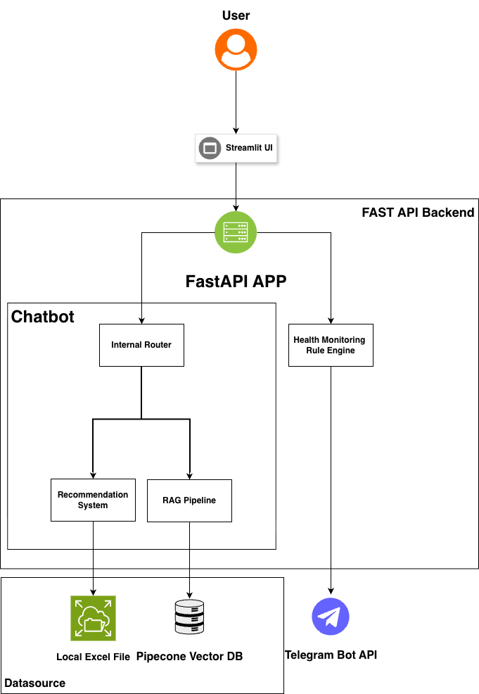

The platform is designed using a client–server framework. The frontend is built with Streamlit and provides a space for users to ask questions or request personalized activity suggestions. FastAPI supports the backend, which combines several main parts that handle the platform’s core functions. These include a rule engine that checks health metrics against set thresholds, an activity recommendation module that identifies suitable activities, a RAG pipeline responsible for producing responses to general health-related queries, and a routing mechanism that examines user input to determine intent and direct it to the right component.

## Component-Level Design

### Health Monitoring Rule Engine

The rule engine evaluates health metrics received from connected wearables and detects readings that fall outside defined thresholds. The platform process four key metrics: heart rate, blood pressure (systolic/diastolic), blood glucose, and blood oxygen. Thresholds were adapted from available health guidelines (American Heart Association, American Stroke Association, Vinmec International Hospital, and National University Health System). The tables below specify the points at which alerts will be triggered and the messages that will be sent when a reading enters an alert range.

* **Heart Rate**

|  |  |
| --- | --- |
| **Input** | **Message** |
| Above 100 | Heart Rate: High. Reading = {heart_rate} |
| Less than 60 | Heart Rate: Low. Reading = {heart_rate} |

* **Blood Pressure**

|  |  |
| --- | --- |
| **Input** | **Message** |
| Systolic above 140 & Diastolic above 89 | Blood Pressure: Signs of stage 2 Hypertension. Reading = {systolic}/{diastolic} |
| Systolic between 130 and 139 & Diastolic above 79 | Blood Pressure: Signs of stage 1 Hypertension. Reading = {systolic}/{diastolic} |
| Systolic between 120 and 129 & Diastolic less than 80 | Blood Pressure: Elevated. Reading = {systolic}/{diastolic} |

* **Blood Glucose**

|  |  |
| --- | --- |
| **Input** | **Message** |
| Above 125 | Blood Glucose: Signs of diabetes. Reading = {blood_glucose} |
| 100 to 125 | Blood Glucose: Signs of pre-diabetes. Reading = {blood_glucose} |
| Less than 70 | Blood Glucose: Signs of low blood sugar. Reading = {blood_glucose} |

* **Blood Oxygen**

|  |  |
| --- | --- |
| **Input** | **Message** |
| 94 to 95 | Blood Oxygen: Borderline Low -> monitor closely. Reading = {blood_oxygen} |
| 90 to 93 | Blood Oxygen: Low -> consult doctor. Reading = {blood_oxygen} |
| Less than 90 | Blood Oxygen: Extremely Low -> medical emergency. Reading = {blood_oxygen} |

When readings fall within the predefined alert ranges, the platform sends a message to the user’s designated caregiver via Telegram. Each message contains a summary of the findings, such as the recorded value and a short description (e.g. Blood Pressure: Signs of stage 2 Hypertension. Reading = 140/90).

### Activity Recommendation

The recommendation model selects appropriate activities for each user by considering factors such as location, interests, budget, language, and preferred time of day. It applies a **three-step hybrid content-based method** that merges rule-based filtering with semantic similarity scoring to produce recommendations that are both relevant and practical.

**Step 1: Rule-based Filtering.** This stage narrows down the activity dataset by excluding options that do not meet basic conditions. Activities are first filtered by language to ensure accessibility. For location, rather than using real-time user coordinates, each user is randomly assigned a location sampled from Singapore’s **HDB Existing Building Dataset**, which serves as a realistic proxy for residential distribution. Distance between this proxy location and each activity is computed using the Haversine formula, but this remains a simulated approximation rather than live geolocation. Time-slot compatibility is incorporated via a graded penalty that reduces the relevance of activities outside the user’s preferred times while not over-penalizing partial overlaps. Budget is respected via a soft penalty on prices above the user’s stated budget; if the user does not provide a budget, a relaxed upper bound is assumed to avoid over-filtering. In addition, if the user prefers free activities, free options receive a small positive bonus so they surface more prominently. These filters and adjustments ensure that only contextually appropriate activities are retained for further ranking.

**Step 2: Semantic Ranking and Composite Scoring.** The remaining activities are ranked using semantic similarity between user inputs and activity descriptions. User interests are embedded and averaged, and activities use precomputed all-MiniLM-L6-v2 embeddings for speed and stability. A lightweight keyword-matching bonus complements semantic similarity to reward direct matches in titles and descriptions. Each activity then receives a composite score that balances interest match, affordability, distance, and timing suitability:

$$Score = αS_{interest} -βP_{price}-γP_{time}-δP_{dis}+B_{free},$$

where $S_{interest}$ is derived from cosine similarity between the user and activity embeddings (plus a capped keyword bonus and a smooth sharpening), $P_{price}$ penalizes prices above the user’s budget, $P_{time}$ encodes time-slot mismatch (graded), $P_{dis}$ applies a mixed linear–quadratic distance penalty, and $B_{free}$ adds a small bonus when the user prefers free activities and the activity is free. Weights $α, β, γ, δ$ are tuneable. The final score is normalized to [0,1] for presentation, ensuring comparability across queries.

**Step 3: Top N Selection and Explanation Generation.** Finally, the system selects the top three activities and generates short, human-readable explanations describing why each was recommended (e.g., matched interest terms, within-budget status, proximity, and time-slot fit). For example: “Social Dance (Adult) – Intermediate (HealthierSG) – Score: 0.821 – This activity strongly matches your interest in dance, art, is within your budget (SGD 105.00), is reasonably near your assigned location, and fits your preferred time window.” When interests are missing, the system provides exploratory recommendations using sensible defaults (e.g., broader filters or free-friendly choices); when location is missing, items are ranked without distance filtering.

### RAG Pipeline

The RAG pipeline supports the chatbot in answering health-related queries by combining information retrieval and language generation.

When a query is received, the input text is first converted into embeddings using the DoubaoEmbeddings model. These embeddings are compared against indexed knowledge documents stored in Pinecone. The top three relevant documents are retrieved based on similarity scores, forming the contextual basis for the response.

The retrieved documents are then passed to a LangChain Question-Answering (QA) chain, which uses a large language model (DeepSeek) to generate a coherent and informative answer. Both the generated answer and the retrieved document snippets with their similarity scores are returned, enabling transparency and easy traceability of the information source.

By combining retrieval with generation, the RAG pipeline enables the chatbot to produce dynamic, contextually relevant, and trustworthy responses to general health enquiries. This architecture reduces the likelihood of hallucinated answers and ensures responses are supported by the underlying dataset.

### Hybrid Routing for Chatbot

The chatbot uses a hybrid routing mechanism to decide how each incoming message is processed. This mechanism integrates rule-based prioritisation, machine learning intent classification, and a RAG fallback to maintain both accuracy and flexibility in managing conversations. When a recommendation intent is detected, a user profile is dynamically built based the user’s prompts. This profile includes preferences such as interests, time slots, budget, and location, ensuring that recommendations are personalised and contextually relevant.

1. **Rule-Based Priority**

The routing process begins with explicit keyword detection. Messages featuring clear intent indicators such as “recommend,” “activity,” “suggestion,” “recommendation,” or “suggest” are identified and routed to the activity recommendation model. This deterministic approach helps ensure that direct user requests are handled efficiently and reduces the likelihood of misclassification.

1. **Machine Learning-Based Intent Classification**

Messages that do not match rule-based keywords are processed by a logistic regression classifier trained on labelled examples. Each message is first encoded into embeddings using the all-MiniLM-L6-v2 model to capture semantic meaning and classify user inputs into one of the three intent types, as shown below.

|  |  |
| --- | --- |
| **Intent Type** | **Handling Logic** |
| recommend_activity | Routed to the activity recommendation model, which generates personalised activity suggestions |
| health_qa | Routed to the RAG pipeline, which retrieves relevant context from the health knowledge base and generates context-aware responses |
| chitchat | Handled with a brief predefined reply to guide users back to relevant topics |

1. **RAG Fallback**

When no clear intent is detected, the routing mechanism defaults to RAG. In this mode, the message is routed to the RAG pipeline, which retrieves relevant context from the health knowledge base and generates a context-aware answer using the large language model. This fallback allows the chatbot to handle general health enquiries even when they do not match predefined intents.

### User Interface

The user interface for this platform is designed with two primary components to facilitate interaction with the platform.

The first component is a health metrics input form used to simulate data that would typically be obtained from wearable devices. As integration with these devices is not part of the present scope, users can manually input important health readings such as blood pressure, blood glucose, oxygen level, and heart rate. This setup enables evaluation of the rule engine in the absence of wearable device connectivity.

The second component is a chatbot interface that lets users interact with the platform through everyday language. Users can ask about health topics or request activity suggestions either by typing or through voice input. When voice input is chosen, the system asks users to record a short message so it can capture the audio. The recording is then sent to Baidu’s speech recognition API, where it is converted into text and forwarded to the chatbot for routing. addition, when activity suggestions are returned by the chatbot, the platform also presents a map that shows nearby options and indicates how each activity relates spatially to the user’s current location.

## Data Design

### Activity

#### Data Ingestion

Activity data was obtained from onePA, a platform that lists various community activities such as courses, events, and interest groups. Selenium took care of the browser automation, moving through pages and managing listings that loaded dynamically. After retrieving the pages, BeautifulSoup examined the HTML and extracted key fields including the title, category, description, venue, and event date and time.

#### Data Cleaning

Activity data from courses, events, and interest groups was processed through several steps to prepare it for analysis. Each dataset was cleaned and normalised to align with a common structure. This involved renaming fields, parsing dates, times, and prices into standard formats, mapping categories into broader groups, and removing incomplete or invalid records. Courses without any remaining capacity were excluded, and text and numeric values were adjusted to maintain consistency across sources.

Geographical coordinates were added by matching each activity’s organising community club to its latitude and longitude. Entries without valid coordinates were dropped, and all records were labelled with a source type to identify their origin (courses, event or interest group). The cleaned datasets were then combined into a single unified table, where missing non-text fields were filled with “NA,” and duplicates were removed to produce an analysis-ready dataset.

#### Schema

|  |  |  |
| --- | --- | --- |
| **Column** | **Example** | **Description** |
| id | C027175700 | Unique activity identifier |
| title | Chinese Calligraphy | Activity name |
| category | Leisure_Culture | Standardised top-level category |
| subcategory | Visual Arts (Calligraphy) | Combined secondary category |
| language | CHINESE | Language of the activity |
| enrolled | 4 | Current sign-ups |
| capacity | 20 | Max capacity |
| date | 03 Oct 2025 - 21 Nov 2025 | Date or date range text |
| sessions | 8 | Number of sessions |
| start_time | 07:15 PM | Start time |
| end_time | 09:15 PM | End time |
| time_slot | evening | Derived bucket (e.g. morning, afternoon, evening) |
| registration_closing_date | 30 Sep 2025 | Registration closing date |
| price_num | 163 | Normalised priced in SGD |
| is_free | 0 | 1 if free else 0 |
| description | Learn the correct brush handling and writing techniques are emphasised to help participants acquire an understanding of the art of Chinese calligraphy. | Activity description text |
| requirements | Open for 12 years old & above (adult)   $48 of material fees to be paid to trainer | Participation requirements |
| venue | All Sessions: Activity Room 3 ( All Dates ) | Venue text |
| organising_commitee | Tampines West CC | Organiser name |
| lat | 1.348751 | Latitude of venue |
| lon | 103.9356 | Longitude of venue |
| organising_commitee_url | https://www.onepa.gov.sg/courses/search?course=&outlet=Tampines West CC&showAllResults=true | Link to organiser page |
| training_provider(s) | Lin Yu Ming | Trainer or provider name |
| training_provider(s)_url | https://www.onepa.gov.sg/trainers/lin-yu-ming-39aca9b79f67e61180d900155dad210b | Link to trainer or provider profile |
| pageUrl | https://www.onepa.gov.sg/courses/chinese-calligraphy-c027175700 | Source listing URL |
| imageurl | https://www.onepa.gov.sg/-/media/images/courses/lifestyle-leisure/visual-arts/calligraphy/calligraphy-0.jpg?h=350&iar=0&w=1440&rev=e2d53feb3e0e4cac94b95dd84e8ad9b8&hash=A065EF0539A4E9301AFDAA5FA88E4435 | Image URL for the listing |
| source_type | course | Origin (e.g. course, event, interest group) |

# System Development

## Implementation Process

### Development Methodology

Given the academic nature of the project and a short development window of roughly ten man-days, a mixed approach was adopted to manage the work effectively. The platform was divided into distinct modules, which were developed and tested separately. The modules were developed in parallel so the team could use time more effectively and avoid delays. The group also adopted a few agile practices, meeting regularly to check progress, discuss problems, and adjust plans as needed. This helped keep work moving and ensured the project stayed within schedule.

### Development

Development began with the frontend, where the Streamlit interface was created to enable user interaction. The backend was developed in parallel across three sub-groups.

Sub-group 1 focused on the rule engine, which processed user health metrics and triggered alerts based on predefined conditions. Sub-group 2 developed all chatbot-related modules, including the RAG pipeline and the chat routing mechanism, which enabled incoming queries to be classified and directed internally to the appropriate processing components. Sub-group 3 worked on the recommendation model and data ingestion pipeline, preparing and structuring community activity data for use in activity recommendation.

The parallel development approach boosted efficiency, as different teams could work on separate components simultaneously without delays. It also made debugging and iteration faster by allowing issues to be isolated and resolved within individual modules.

### Testing

Testing was carried out throughout development to verify that each part of the platform worked as expected. Unit tests were applied to individual modules, including the rule engine, chatbot routing, RAG pipeline, and recommendation model, to check their outputs under different input conditions. Integration testing followed to ensure smooth data exchange between modules and consistent backend performance. Finally, end-to-end testing confirmed that the platform worked as expected, linking the frontend input with the backend output. These tests showed that the system was stable and performed reliably after integration. Please refer to the Appendices section for testing results.

### Integration

During integration, we combined the independently built backend modules into a unified system and connected them to the frontend interface. The rule engine, chatbot routing, RAG, and recommendation components were connected within a unified FastAPI backend, ensuring smooth data exchange between modules. The Streamlit frontend was then integrated with this backend through RESTful APIs to enable interaction between user inputs and backend responses.

Docker was used to containerize the system, allowing consistent runtime environments across machines during testing and demonstration. The final integrated build was validated locally, confirming that all components operated cohesively and that the platform was ready for full evaluation.

## Tools and Technologies

The platform was developed mainly in Python, supported by several libraries and frameworks that handled specific functions. The table below summarises these tools and the roles they served in the system.

|  |  |  |
| --- | --- | --- |
| **Category** | **Tool / Library** | **Purpose** |
| Frontend Development | * Streamlit | To build the interactive web-based interface for user input and chatbot communication |
| Backend Framework | * FastAPI | To implement RESTful APIs and handle communication between system modules |
| Web Scraping | * Selenium * BeautifulSoup | To extract structured activity listings from onePA for the recommendation model |
| Data Processing | * pandas * NumPy | To clean, normalise, and merge web-scraped data into a format suitable for the recommendation model |
| Chatbot | * DeepSeek-V3 * SentenceTransformer * scikit-learn * Baidu Speech Recognition API | To classify intent and route messages to the recommendation model or RAG module, and to handle user chat interactions through voice |
| RAG Pipeline | * DeepSeek-V3 * DoubaoEmbeddings * LangChain * Pinecone | To support retrieval-augmented generation for answering health-related queries |
| Activity Recommendation Model | * SentenceTransformer * scikit-learn * haversine | To generate embeddings and match activities based on relevance and proximity |
| Rule Engine for Health Monitoring | * Telegram Bot API | To send automated alerts when abnormal readings are detected |
| Deployment | * Docker | To ensure consistent runtime environments |
| Version Control and Collaboration | * Github | Managed version control and facilitated collaboration |

# Findings

**Lack of real user feedback for the recommender.** Our current ranking quality is grounded in offline heuristics—interest similarity, distance penalty, budget/price fit, and time-slot fit—plus internal review during demos, but we do not yet have click-through or satisfaction labels from real seniors. To address this, we will run a 2-week pilot with 10–15 seniors and 2–3 community staff, collecting Top-1/Top-3 relevance ratings (Likert 1–5), CTR and dwell time in the UI, and short “reason-for-click” notes. We will define success as at least 70% of Top-3 items rated “useful” and a CTR of at least 20% on session recommendations, then use the results to recalibrate weights and validate distance/price trade-offs.

**Static activity corpus (web-scraped OnePA).** Our dataset is currently a static snapshot, so newly added or canceled activities are not reflected in real time, which can undermine freshness and trust. We plan to explore collaboration with the relevant government/agency teams for API access or scheduled data feeds, implement incremental synchronization (hourly or daily), handle soft-deletes for canceled items, and surface a clear “Freshness” tag in the UI. When the upstream API is unavailable, the system will fall back to cached results with a visible timestamp to maintain availability and transparency.

**Cold-start and coverage.** In the absence of long-term interaction logs, interest vectors rely on a brief self-reported profile that may miss niche preferences (e.g., caregiver-friendly events or slow-paced outdoor activities). To mitigate this, we will add a two-question onboarding quiz (e.g., “prefer free/indoors/morning?”), deliberately diversify the first screen with an exploration band to encourage discovery, and capture lightweight implicit feedback (hide/skip) to iteratively refine user profiles and broaden coverage.

# References

1. *Ministry of Health. (2023). Living Life To The Fullest: 2023 Action Plan for Successful Ageing. Retrieved October 8, 2025, from https://www.moh.gov.sg/docs/librariesprovider5/default-document-library/refreshed-action-plan-for-successful-ageing-2023.pdf*
2. *Ministry of Health. (2023, November 16). AGE WELL SG TO SUPPORT OUR SENIORS TO AGE ACTIVELY AND INDEPENDENTLY IN THE COMMUNITY. Retrieved October 8, 2025, from https://www.moh.gov.sg/newsroom/age-well-sg-to-support-our-seniors-to-age-actively-and-independently-in-the-community*

# Appendices

## Appendix A – Output from Activity Recommendation Model

This appendix presents examples of the recommendation model’s outputs. Each example shows a user query and the system-generated response.

**Example 1**

**Example 2**

**Example 3**

This example shows our chatbot system has implemented **context management feature.** If the user has asked a follow up question, our system is still able to identify the user’s previous input and provide an accurate recommendation result.

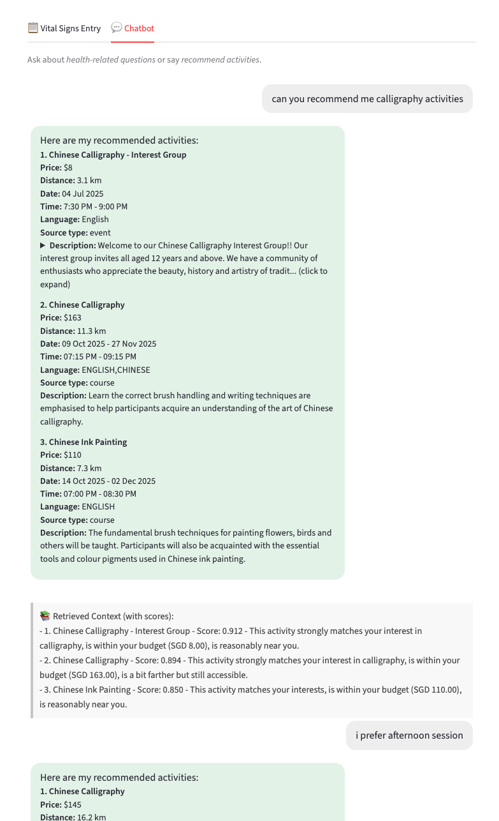

Cont.

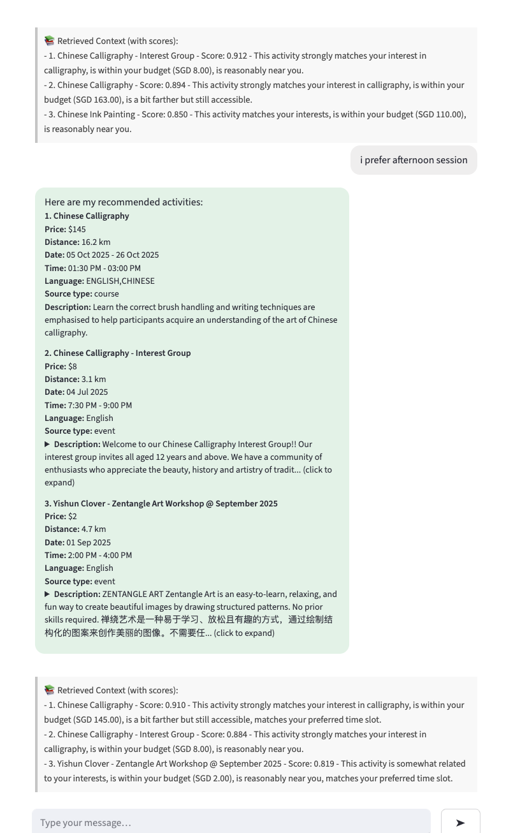

Cont.

We also display the current user location (random generated) and the location and other details of the recommendation results.

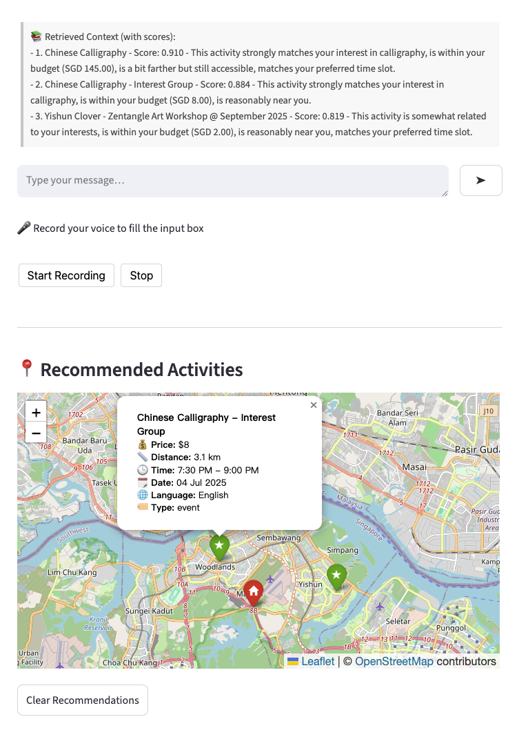

## Appendix B – Output from RAG

This appendix presents examples of the RAG outputs. Each example shows a user query and the system-generated response.

**Example 1**

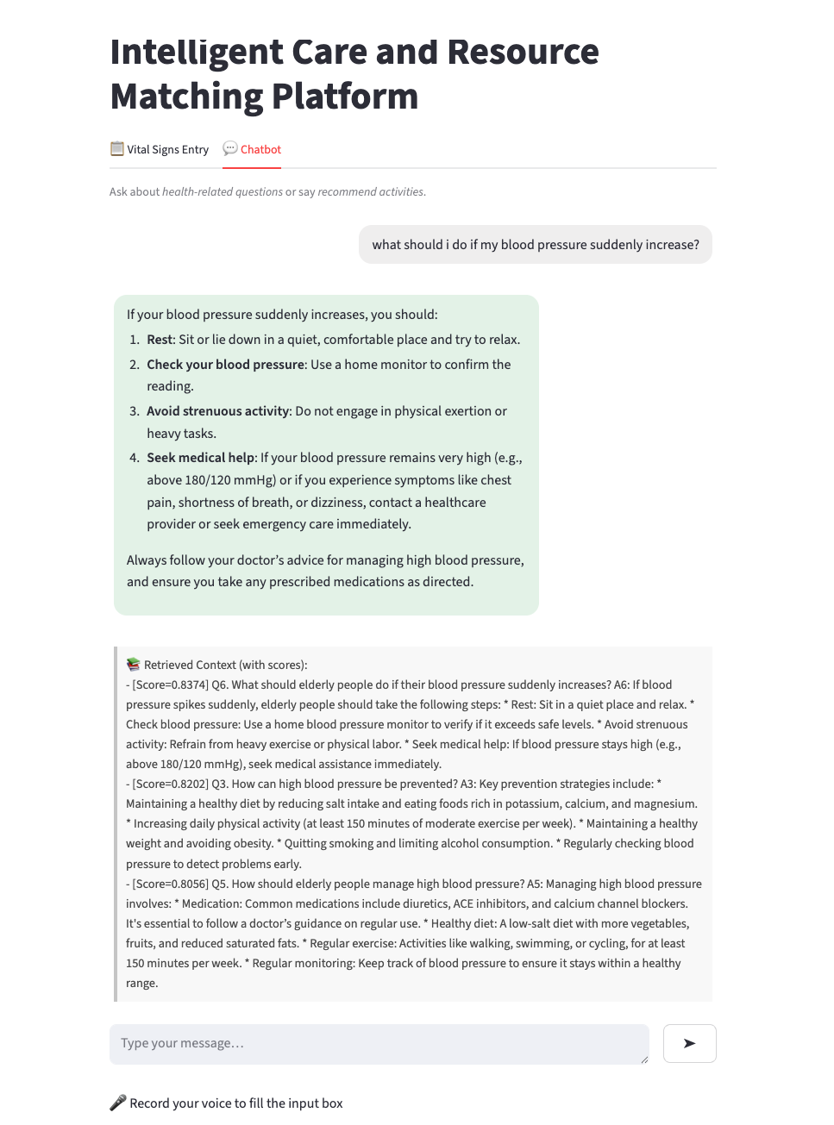

## Appendix C – Output from Rule-based Engine

This appendix presents examples of the Rule engine outputs. Each example shows alert via Telegram is being triggered if rule conditions matched.

Simulated inputs from the wearable device

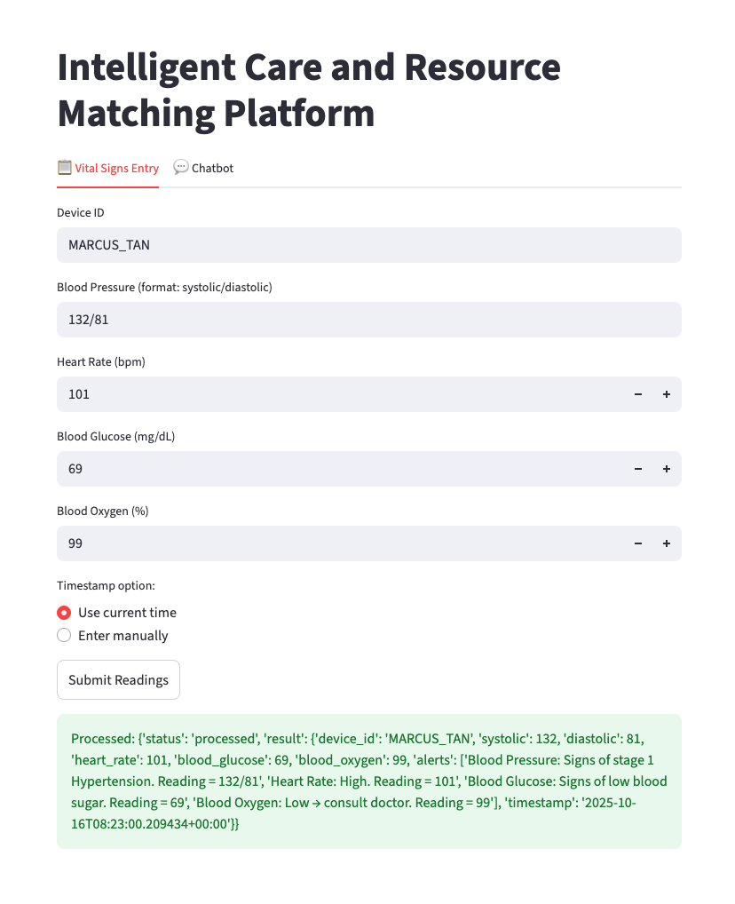

Cont.

Alerts triggered to caregivers via Telegram

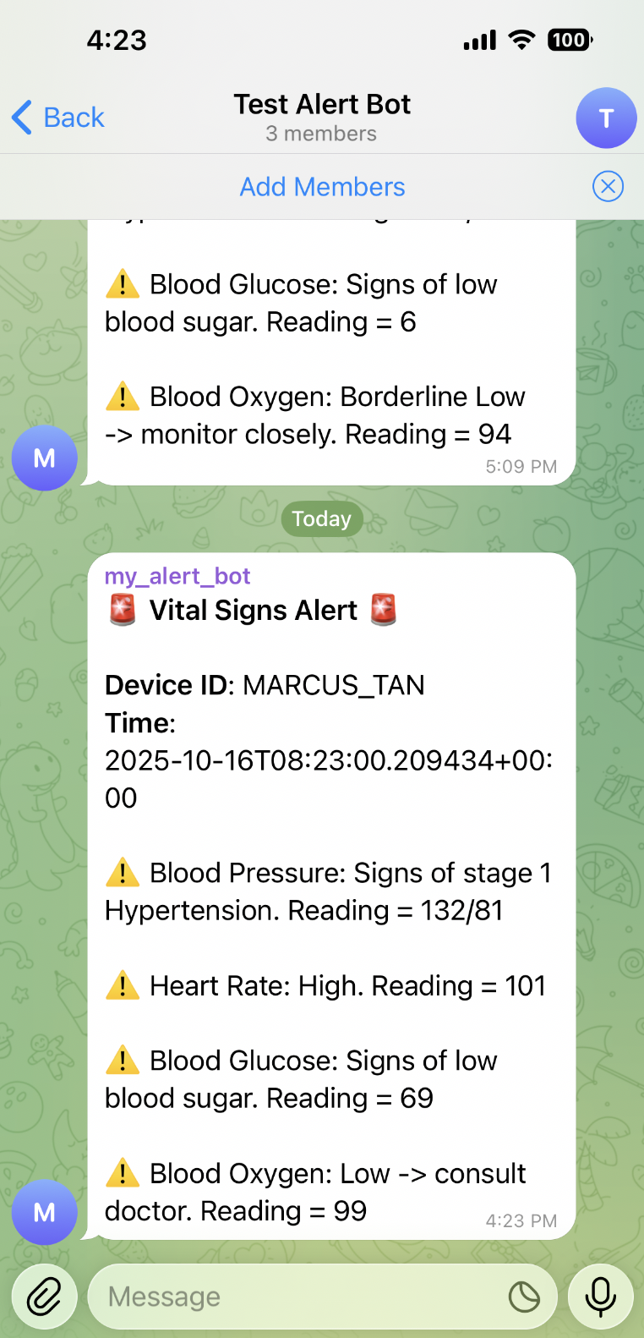

## Appendix D – Project Proposal

This appendix includes the original project proposal that was submitted earlier. The project proposal is attached as a PDF below.



## Appendix E – Mapped System Functionality to Course Knowledge

|  |  |
| --- | --- |
| **System Functionality** | **Course Knowledge** |
| Health Monitoring Rule Engine | Decision automation via business rules |
| Activity Recommendation Model | Similarity-based reasoning using vector embeddings, cosine similarity, and haversine distance to recommend activities semantically and geographically aligned with user interests and constraints |
| Chatbot | Natural language understanding through sentence embeddings and intent classification to determine user intent |

## Appendix F – Installation & User Guide

### Part 1: Installation Guide

#### System Requirements

* **Software Requirements:**
  + Docker ([Download here](https://www.docker.com/products/docker-desktop/))
* **Accounts & API Keys Needed:**

|  |  |
| --- | --- |
| **Service** | **Where to Get** |
| Doubao API | [VolcEngine](https://www.volcengine.com/docs/82379/1399008#b00dee71) |
| Pinecone vector database (2560 Dimensions) | [Pinecone](https://docs.pinecone.io/guides/projects/manage-api-keys) |
| Telegram Bot | [BotFather](https://t.me/botfather) |
| Baidu Speech Recognition API | [Baidu Cloud](https://cloud.baidu.com/product/speech) |

#### Getting Started

1. **Clone the repository**

git clone <https://github.com/hongming-github/IRS-PM-2025-08-18-AIS07FT-LionLogic-Intelligent_Care_and_Resource_Matching_Platform.git>  
  
cd IS Project

1. **Create an “*.env”* file in the project root and configure API keys / tokens**

#Doubao API

OPENAI_API_KEY=<your-api-key>

OPENAI_API_BASE=https://ark.cn-beijing.volces.com/api/v3

#Pinecone API Key

PINECONE_API_KEY=<your-api-key>

PINECONE_ENVIRONMENT=<your-env>

#Telegram Bot Token

TELEGRAM_BOT_TOKEN=<your-telegram-bot-token>

CHAT_ID=<your-chat-id>

#Baidu API Key

BAIDU_API_KEY=<your-api-key>

BAIDU_SECRET_KEY=<your-secret-key>

1. **Build and start services**

docker compose up --build

1. **Train intent classifier – *run once during setup***
   1. Before using the chatbot, train the classifier:

docker compose run --rm fastapi python backend/chatbot/train_intent.py

* 1. Upon running the command above, it should generate the following:

backend/chatbot/intent_clf.pkl

1. **Build the RAG index –*run once during setup***
   1. To add or update knowledge base documents (i.e. elderly_health_qa.txt), you must rebuild the index. This uploads the embeddings to Pinecone and makes them available for retrieval.

docker compose run --rm fastapi python backend/chatbot/build_index.py

1. **Restart services after training**
   1. Upon running the following command, the chatbot can classify intents using the trained classifier and the RAG pipeline will be able to answer knowledge-based questions.

docker compose up

1. **Access Application**
   1. Access the application through your browser at http://localhost:8501

### Part 2: User Guide

#### Getting Started

To initiate the application:

1. Launch a terminal interface and navigate to the project directory

cd IS Project

1. Execute the following command:

docker compose up

1. Access the web interface at <http://localhost:8501>

#### Features

This application provides an integrated platform that enables health monitoring and a chatbot interface that allows users to request personalized activity recommendations and ask health-related questions.

##### Health Monitoring Rule Engine

This interface allows users to simulate incoming health readings without the use of actual devices for testing and demonstration purposes.

Upon submission, the system evaluates it against defined rules. If the reading exceeds the threshold, a Telegram notification will be triggered.

##### Chatbot

The chatbot is the primary interface through which users interact with the system. It enables both text and voice communication for:

* Requesting personalized activity recommendations
* Asking health-related questions

**Accessing the Chatbot**

Select the “Chatbot” tab from the main web interface to access the chatbot feature.

**Speech Interaction**

The speech recognition feature allows users to interact with the chatbot using their voice instead of typing.

**Steps:**

1. Click the “Start Recording” button to begin recording.
2. When prompted, select either “Allow while visiting the site” or “Allow this time” to enable microphone access.

1. When recording is in progress, a red dot icon appears on the browser tab, indicating that the microphone is active and ready for input.

1. Click the “Stop” button to end recording. The system then begins transcribing your voice recording, indicated by a person icon at the top-right corner.

1. When transcription is complete, the transcribed text appears in the chat window. Click the “right arrow” icon to submit your message to the chatbot.

##### Activity Recommendation

This feature allows users to request personalized activity recommendations directly through the chatbot. Based on the user’s stated interests, preferences, and constraints (e.g. time or budget), the chatbot suggests up to three suitable activities along with relevant details such as price, distance, schedule, and description.

**Steps:**

1. In the chatbot interface, type or say a message asking for activity suggestions and submit it to the chatbot. Refer below for some examples:
   * *Recommend me some yoga classes available in the evening*
   * *Show me mindfulness workshops*
   * *Find baking classes under $120*
2. The chatbot displays the top three recommended activities, each showing details such as activity name, price, distance from home, date and time, language, type of activity (e.g. course, interest group), and description of activity.

1. Each suggestion includes a brief explanation of why it was recommended, providing transparency in the recommendation model’s reasoning.

1. A map appears below the chatbot to visualize the distance between the home location and the suggested activities.
   * The home icon represents the user’s location.
   * The star icons indicate the activity locations. Selecting a star icon reveals additional details such as price, distance, time, date, language, and type of activity (e.g. course, interest group).

##### Health-related Q&A

This feature allows users to ask health-related questions through the chatbot and receive informative responses drawn from the system’s knowledge base. The chatbot retrieves and summarizes relevant information from the knowledge base to provides useful insights on health-related questions.

**Steps:**

1. In the chatbot interface, type or say a health-related question. Refer below for some examples:
   * *What is considered a healthy heart rate range?*
   * *What factors can cause high blood glucose levels?*
   * *How can I lower my blood pressure?*
2. The chatbot provides an answer based on information retrieved from the indexed health knowledge base.

1. To improve transparency, the chatbot displays the retrieved context from the knowledge base, including similarity scores showing how closely each source matches the query.

